INTERNATIONAL TEAM
OUR CIRCUIT:
*COORDINATOR – MARC RAMOS
*SPEAKER – ADRIAN JORDAN
*COMPUTER – EMERSON BLANZA
*SECRETARY – EMERSON BLANZA
*INVENTOR– ATHOS PHILALITHES
EXS : ALL BODY (CHOOSE ONE)
- GAC
- UPPER BODY
- LOWER BODY
· PRINCIPAL MATERIAL: TIRES ELASTIQUES …
· HOW MANY REPS , AND HOW MANY TIME TO REST –
· CLASS IN GROUPS
·EXS 1: ABS - Abdominals
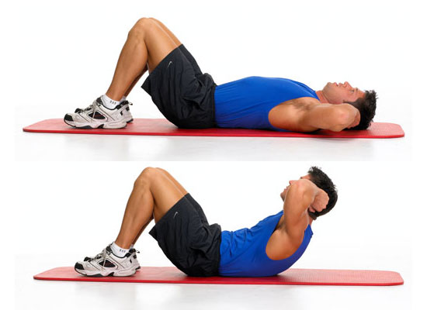
·EXS 2: BICEPS WITH ELASTICS TAPE - biceps
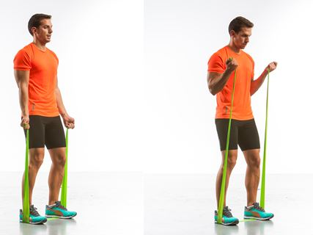
·EXS 3: NORMAL PLANC - abdomiales, gluteos, obliquos
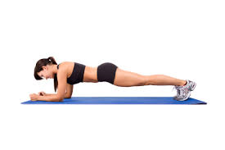
·EXS 4: SHOULDERS WITH DUMBBELS (DUMBBLES NO, BALLS) - pectoral, triceps, hombro
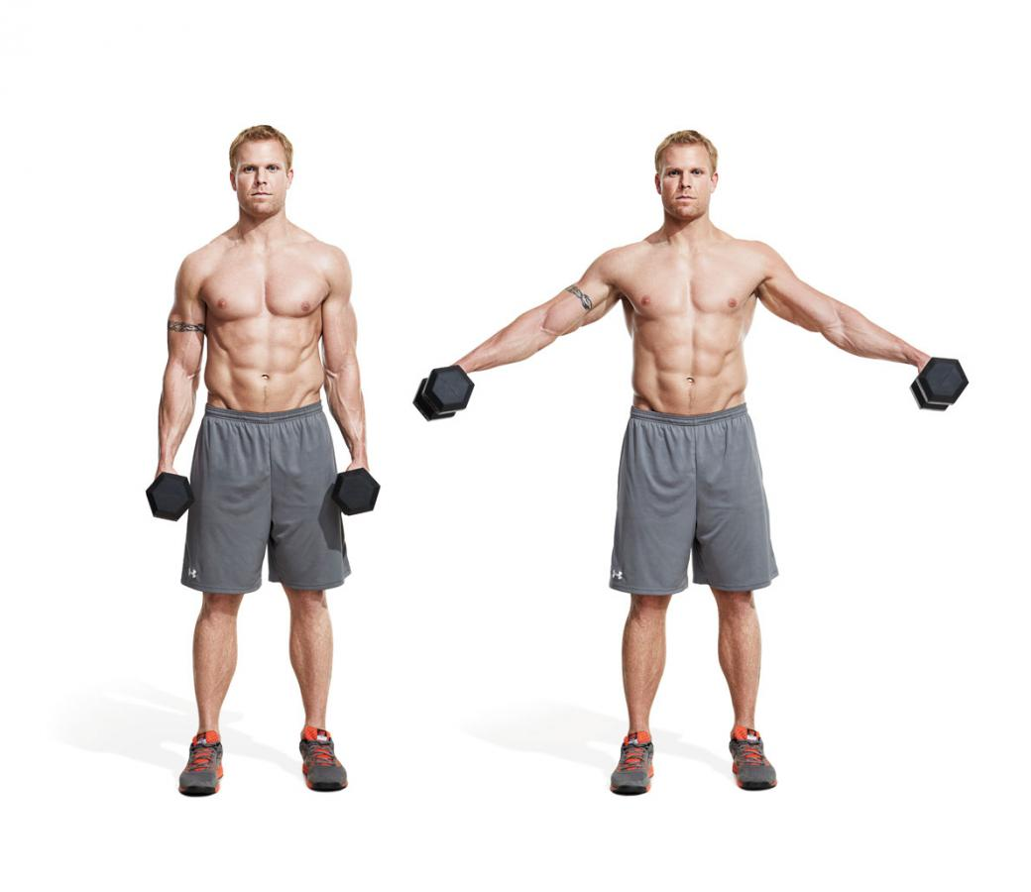
·EXS 5: ABS LIFTING LEGS. - abdominal inferior
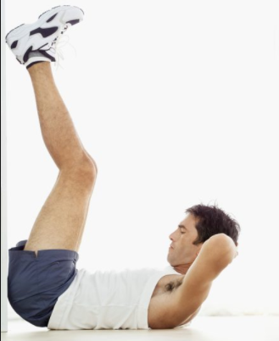

·EXS 6: PUSH-UPS OF SHOULDERS. - hombro,
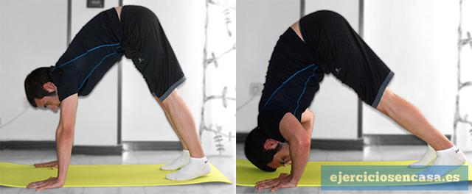

·EXS 7:BENCH EXCERCICE (NO DUMBBLES, A STICK) - quadriceps
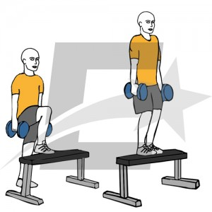

·EXS 8: PUSH-UPS. - biceps, deltoide, pectoral
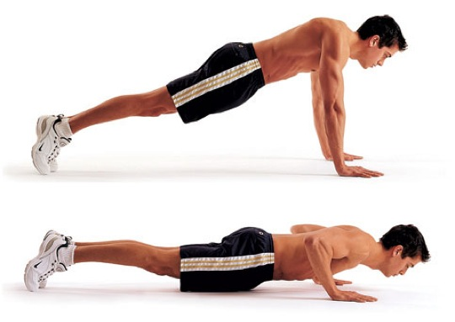

·EXS 9: ABS TOUCH KNEE obliquos
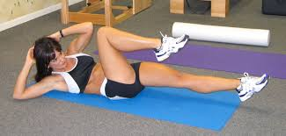

·EXS 10:Abdominal excercice(get up the low body) - abdominal inferior
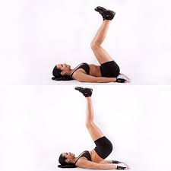
·EXS 11: PLANC STANDING ARM(DIFFERNTS EXCERCICES) - abdominales y obliquos

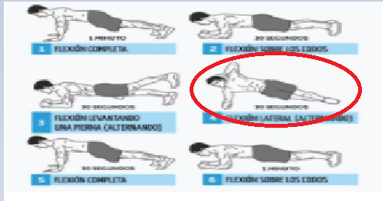

·EXS 12: DIPPINGS - triceps, deltoide, hombro
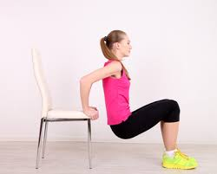

ORDER OF THE CIRCUIT.

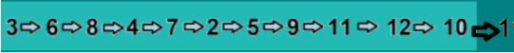

·Cançons:
You don’t know me: https://www.youtube.com/watch?v=PKB4cioGs98
Light it up: https://www.youtube.com/watch?v=r2LpOUwca94
The spectre: https://www.youtube.com/watch?v=wJnBTPUQS5A
Loyal: https://www.youtube.com/watch?v=JXRN_LkCa_o
Believe: https://www.youtube.com/watch?v=7wtfhZwyrcc

Bona feina!

Heu d'afegir alguna informació.

* COORDINADOR - MARC RAMOS

¿Va a controlar el circuit, preparar-lo i posar el material al lloc?

* SPEAKER - ADRIAN JORDAN

Va a parlar i explicar el circuit?

* COMPUTADOR - EMERSON BLANZA

* SECRETARI - EMERSON BLANZA

Va a controlar el temps? I pren notes sobre l'activitat?

* INVENTOR: ATHOS PHILALITHES

Va a fer els exercicis de diferència?

· MATERIAL PRINCIPAL: TIRES ELASTIQUES (número?) De qualsevol altre material? 🤔

· QUAN MANY REPS, I QUALSEVOL TEMPS DE RESTA -

No l'heu omplert
· CLASSE EN GRUPS: treballes amb grups? Quanta gent?

Glòria

HELLO WE ARE THE INTERNATIONAL TEAM
HE ‘S ATHOS PHILATITES, HE MARC RAMOS,HE EMER BLANZA AND ME ADRIÁN JORDÁN
TO DO THE EXERCICES YOU NEED TO MAKE GROUPS OF 3 OR 4. AND YOU DO EVERY EXERCICE 2 TIMES OF 30 SECONDS EVERYONE.(YOU HAVE BREAKS OF 10 SECONDS FOR STATION )

WE ARE GOING TO EXPLAIN OUR CIRKIIT :
(3)· IN THE FIRST STATION YOU WERE GOING TO DO THE A NORMAL PLANC: YOU WORK THE ASS AND ABDOMINAL.
(6)·IN THE SECOND STACION YOU WERE GOING TO DO PUSH UPS OF SHOULDERS: YOU WORK THE SHOULDER.
(8) ·NEXT YOU ARE GOING TO DO PUSH-UPS: YOU WORK BICEPS,DELTOID,PECTORAL
AT THE 4th.
(4) ·you are going SHOULDERS WITH DUMBBELS: you work Pectoral triceps shoulder

(7)·IN THE NEXT STATION, Y’ALL ARE GONNA DO BENCH EXERCISES, WITH A STICK BEHIND OUR SHOULDERS. YOU WORK THE QUADRICEPS.
(2)· TO CONTINUE WITH THE CIRCUIT YOU ARE COME TO DO BICEPS WITH ELASTIC TAPES:YOU WORK (BICEPS)
(5)· IN THIS STATION, Y’ALL ARE GOING TO DO ABS LIFTING LEGS. YOU WORK THE INFERIOR ABDOMINAL.
(9) ·AT THE 8 EXCERCICES YOU DO ABS BUT TOUCHING THE KNEE:YOU WORK (LATERAL ABS)
(11) ·AT THE NEXT YOU ARE TO DO FLEXIBLE LATERAL ABDOMINAL:YOU WORK (ABDOMINALS)
(12) ·AT THE 10th STACION YOU DO dippings: YOU WORK (triceps, deltoid, shoulder)
(10) ·At THE 11th STATION YOU DO Planc in one arm. Then you change your arm. You work obliquos
- ·AT THE 12th STATION YOU DO dippings: you go down flexing your arms. You work triceps deltoide shoulder

